National University of Computer and Emerging Sciences

Lab Manual

Computer Organization and Assembly Language



Lab 10

|  |  |
| --- | --- |
| **Instructor** | Hazoor Ahmad/ Rida Mehmood |
| **Class** | CS3 |
| **Semester** | Fall 2022 |

Fast School of Computing

FAST-NU, Lahore, Pakistan

# Objectives

* Hardware/Software Interrupts
* Graphics Mode
* Video Memory
* Design 2D Graphics

**Contents**

Objectives 2

ACTIVITY 1: [50 Marks] 2

ACTIVITY 2: [50 Marks] **Error! Bookmark not defined.**

REFERENCES 3

**Note for all questions**: You can make as many memory variables, subroutines as you need. Must read all the manual before starting.

## ACTIVITY 1: [50 Marks]

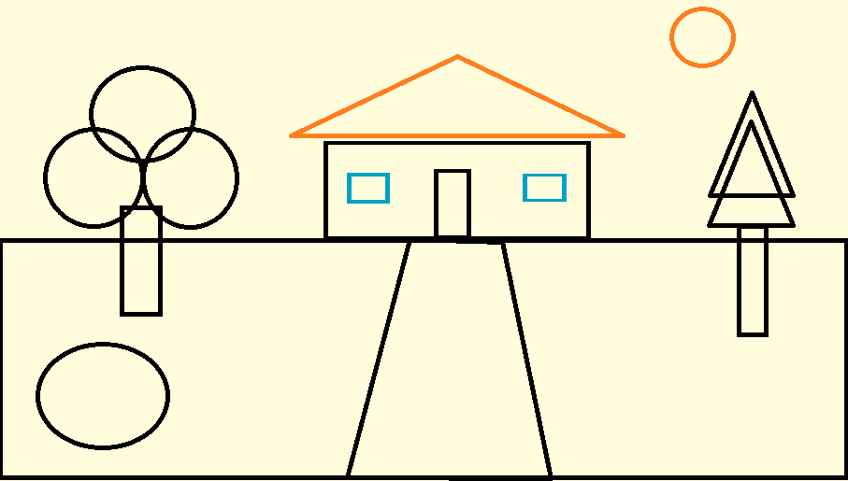In the previous lab, you have used **int 10h** for graphics displaying a Diamond using **AX = 0x000D service** which extended your graphic resolution to 320 X 200. This lab is using **AX = 0x0010 service** which extended your graphic resolution to 640 X 350.

**Write a comprehensive program which:**

1. Generates an animation for the line drawing shown in the attached picture.
2. Your program should start working on the animation after you press any key from the keyboard.
3. Once the animation is finished you should your program should wait for key press before moving forward.
4. Circle drawing programs are given to you, for printing

**[hint]**

Use the Circle Drawing program in **the Appendix**. For more information about the graphics mode please refer to [1] and Chapter 12 of textbook.

## REFERENCES

1. <http://vitaly_filatov.tripod.com/ng/asm/asm_023.1.html>
2. http://www.dosbox.com/download.php?main=1
3. <http://sourceforge.net/projects/nasm>
4. <http://www.nasm.us/>
5. [http://www.programmersheaven.com/download/21643/download.aspx (AFD)](http://www.programmersheaven.com/download/21643/download.aspx)

## Appendix

; circle in graphics mode

[org 0x0100]

jmp start

; coordinates of a circle of radius 24

x24: dw 48,47,44,40,36,30,24,17,12,7,3,0,0,0,3,7,11,17,23,30,36,40,44,47,48

y24: dw 24,30,36,40,44,47,48,47,44,40,36,30,24,17,11,7,3,0,0,0,3,7,11,17,23

; coordinates of a circle of radius 45

x45: dw 90,89,88,86,83,79,75,70,64,58,52,46,40,34,28,22,17,12,8,5,2,0,0,0,0,2,5,8,12,17,22,28,34,40,46,52,58,64,70,75,79,83,86,88,89,90

y45: dw 45,51,57,63,68,73,78,82,85,87,89,89,89,88,86,83,80,76,71,66,60,54,48,41,35,29,23,18,13,9,6,3,1,0,0,0,2,4,7,11,16,21,26,32,38,44

; coordinates of a circle of radius 72

x72: dw 144,143,142,141,139,137,134,130,127,122,118,113,108,102,96,90,84,78,72,65,59,53,47,41,36,30,25,21,16,13,9,6,4,2,1,0,0,0,1,2,4,6,9,13,16,21,25,30,35,41,47,53,59,65,71,78,84,90,96,102,108,113,118,122,127,130,134,137,139,141,142,143,144

y72: dw 72,78,84,90,96,102,108,113,118,122,127,130,134,137,139,141,142,143,144,143,142,141,139,137,134,130,127,122,118,113,108,102,96,90,84,78,72,65,59,53,47,41,35,30,25,21,16,13,9,6,4,2,1,0,0,0,1,2,4,6,9,13,16,21,25,30,35,41,47,53,59,65,71

; coordinates of a circle of radius 120

x120: dw 240,239,239,238,237,235,234,232,229,226,223,220,217,213,209,204,200,195,190,185,180,174,168,163,157,151,144,138,132,126,120,113,107,101,95,88,82,76,71,65,60,54,49,44,39,35,30,26,22,19,16,13,10,7,5,4,2,1,0,0,0,0,0,1,2,4,5,7,10,13,16,19,22,26,30,35,39,44,49,54,59,65,71,76,82,88,95,101,107,113,119,126,132,138,144,151,157,163,168,174,180,185,190,195,200,204,209,213,217,220,223,226,229,232,234,235,237,238,239,239,240

y120: dw 120,126,132,138,144,151,157,163,168,174,180,185,190,195,200,204,209,213,217,220,223,226,229,232,234,235,237,238,239,239,240,239,239,238,237,235,234,232,229,226,223,220,217,213,209,204,200,195,190,185,180,174,168,163,157,151,144,138,132,126,120,113,107,101,95,88,82,76,71,65,59,54,49,44,39,35,30,26,22,19,16,13,10,7,5,4,2,1,0,0,0,0,0,1,2,4,5,7,10,13,16,19,22,26,30,35,39,44,49,54,59,65,71,76,82,88,95,101,107,113,119

; setting up the parameters

counter : db 0;

radius : equ 120 ; choose radius (24, 45, 72, 120)

xoffset: equ 0 ; change to move circle along x axis

yoffset: equ 0 ; change to move circle along y axis

start:

mov si, x120 ; change x array as radius

mov di, y120 ; change y array as radius

mov ax, 0x0010 ; set 640 x 350 graphics mode

int 0x10 ; bios video services

mov ax, 0x0C07 ; put pixel in white color

xor bx, bx ; page number 0

mov cx, [si] ; first x position

add cx, xoffset ; moving point along x axis

mov dx, [di] ; first y position

add dx, yoffset ; moving point along y axis

l1:

int 0x10 ; bios video services

add si, 2 ; next location address

add di, 2 ; next location address

mov cx, [si]

add cx, xoffset

mov dx, [di]

add dx, yoffset

inc byte[counter]

cmp byte[counter], radius ; stopping condition

jle l1 ; jump if less

mov ah, 0 ; service 0 – get keystroke

int 0x16 ; bios keyboard services

mov ax, 0x0003 ; 80x25 text mode

int 0x10 ; bios video services

mov ax, 0x4c00 ; terminate program

int 0x21